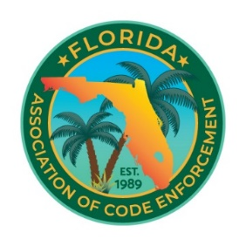

Florida Association of Code Enforcement
Board of Directors Virtual Meeting
August 14, 2024 at 2:00 PM – 4:00 P.M

Call to Order
Roll Call
Approval of Agenda
Approval of Minutes
- June 10, 2026 – Annual Meeting
- June 13, 2026 – Post-Conference Meeting
Old Business
New Business
- Goals and priorities for each Board position and Committee Chair
- Moving certification exams online
- Offering online training classes
- Expanding and strengthening FACE's social media presence
  - Website updates and improvements
- Legislative response process
  - Providing timely feedback on proposed legislation and legislative issues
- Member survey to better understand our membership
- Legal Case Report Form
- Mosaic – Transition to a year-round conference app
- Scholarship recipient request to defer attendance until the 2028 Conference, as their agency is unable to approve attendance at the 2027 Conference
Good of the Organization
Adjournment

